Siting Tool Social Media Kit & Posts

Help us spread the word on social media about the Voting Location Siting Tool as a great and free resource for communities in your state for informing voter outreach efforts.

Ready-to-go social media posts are below. Simply customize to your state. Need help creating images just for your county or state, or sizing them to specific social media platforms? Email us at WHO?

SAMPLE POST 1

IMAGE
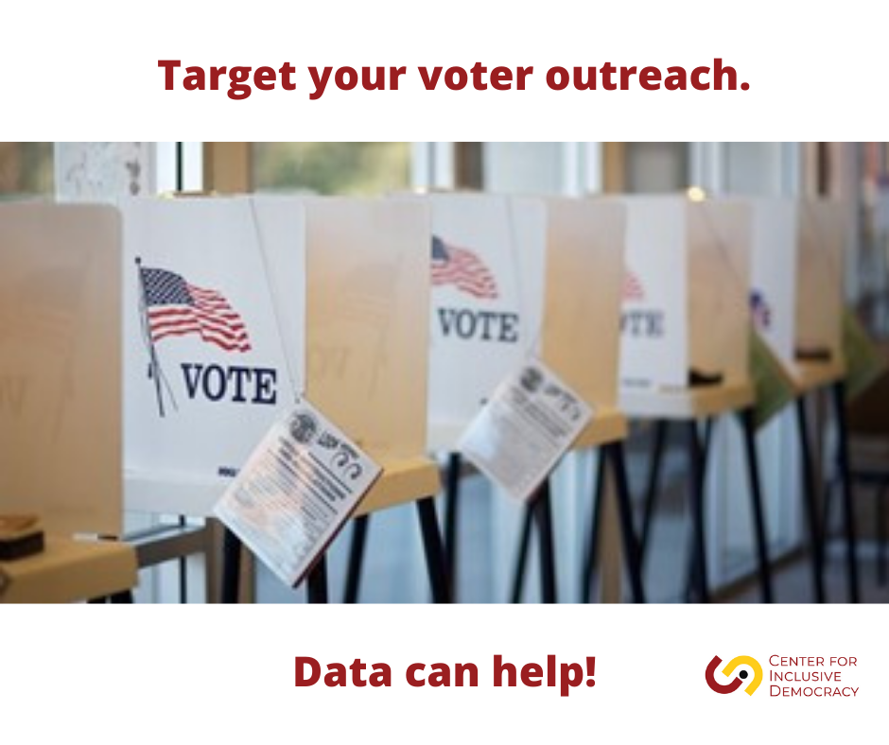
FACEBOOK
Conducting last minute voter outreach? Use the @CIDUSC Voting Location Siting Tool data maps to target specific voter and demographic populations at the community level in our STATE. #2022Elections https://cid.usc.edu/sitingtool

TWITTER
Conducting last minute voter outreach? Use the @CID_USC Voting Location Siting Tool data maps to target specific voter and demographic populations at the community level in our STATE. #2022Elections https://cid.usc.edu/sitingtool

SAMPLE POST 2

IMAGE
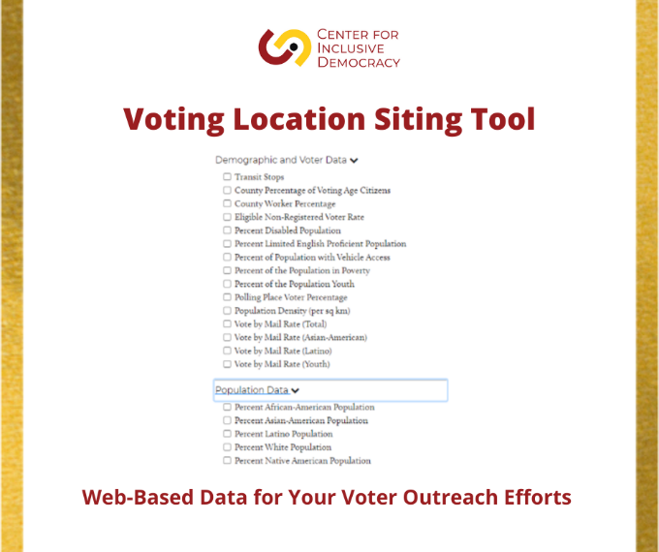

FACEBOOK
Voter outreach using big data? Yes, it’s possible using the @CIDUSC Siting Tool. It’s a GREAT resource for targeting voter outreach in communities throughout STATE as midterm elections get underway. #2022Elections https://cid.usc.edu/sitingtool

TWITTER
Voter outreach using big data? Yes, it’s possible using the @CID_USC Siting Tool. It’s a GREAT resource for targeting voter outreach in communities throughout STATE as midterm elections get underway. #2022Elections https://cid.usc.edu/sitingtool

SAMPLE POST 3

IMAGE
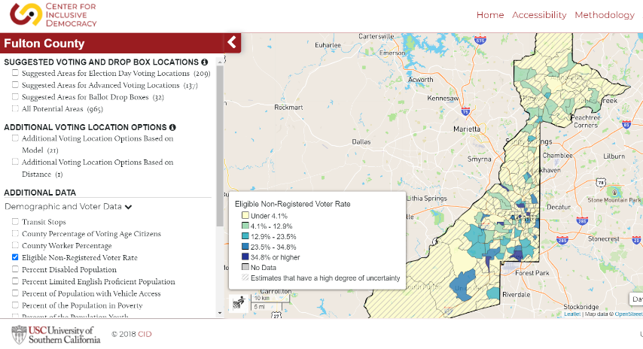

FACEBOOK
The @CIDUSC Voting Location Siting Tool features robust digital maps of demographic & voter data for the most populous counties in STATE. A GREAT resource for hyper-local voter education & outreach—like this example of eligible non-registered voter rates in Fulton County, GA. https://cid.usc.edu/sitingtool

TWITTER
The @CID_USC Voting Location Siting Tool features robust digital maps of demographic & voter data for the most populous counties in STATE. A GREAT resource for hyper-local voter education & outreach—like this example of eligible non-registered voter rates in Fulton County, GA. https://cid.usc.edu/sitingtool

SAMPLE POST 4

IMAGE
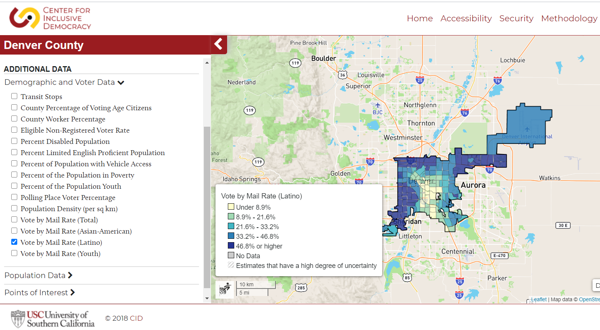

FACEBOOK
Do you know how many Latinos voted by mail in your county in 2020? We do! Because we used the @CIDUSC online data mapping Siting Tool. Same info also for Black, White, Asian & Youth populations in STATE, like this example from Denver County, CO. https://cid.usc.edu/sitingtool

TWITTER
Do you know how many Latinos vote by mail in your county in 2020? We do! Because we used the @CID_USC online data mapping Siting Tool. Same info also for Black, White, Asian & Youth populations in STATE, like this example from Denver County, CO. https://cid.usc.edu/sitingtool

